CAROLS
“come and sing with your family”
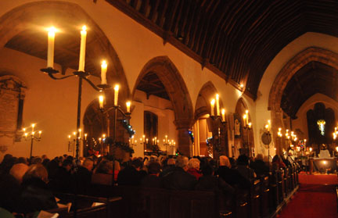
At St Michaels & All Angels
Teffont Evias
6pm on Sunday 17th December
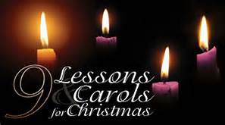
An all star cast and front seats for children
Do bring a small pocket torch to light your way to the Church and in case you need extra light to read the carol book

